ADSD HW9 Aggregation

In this homework I will mongodb as main test databset.

I use mongodb://<dbuser>:<dbpassword>@ds027415.mongolab.com:27415/todoshuchang

Mongo command line to test aggregation.

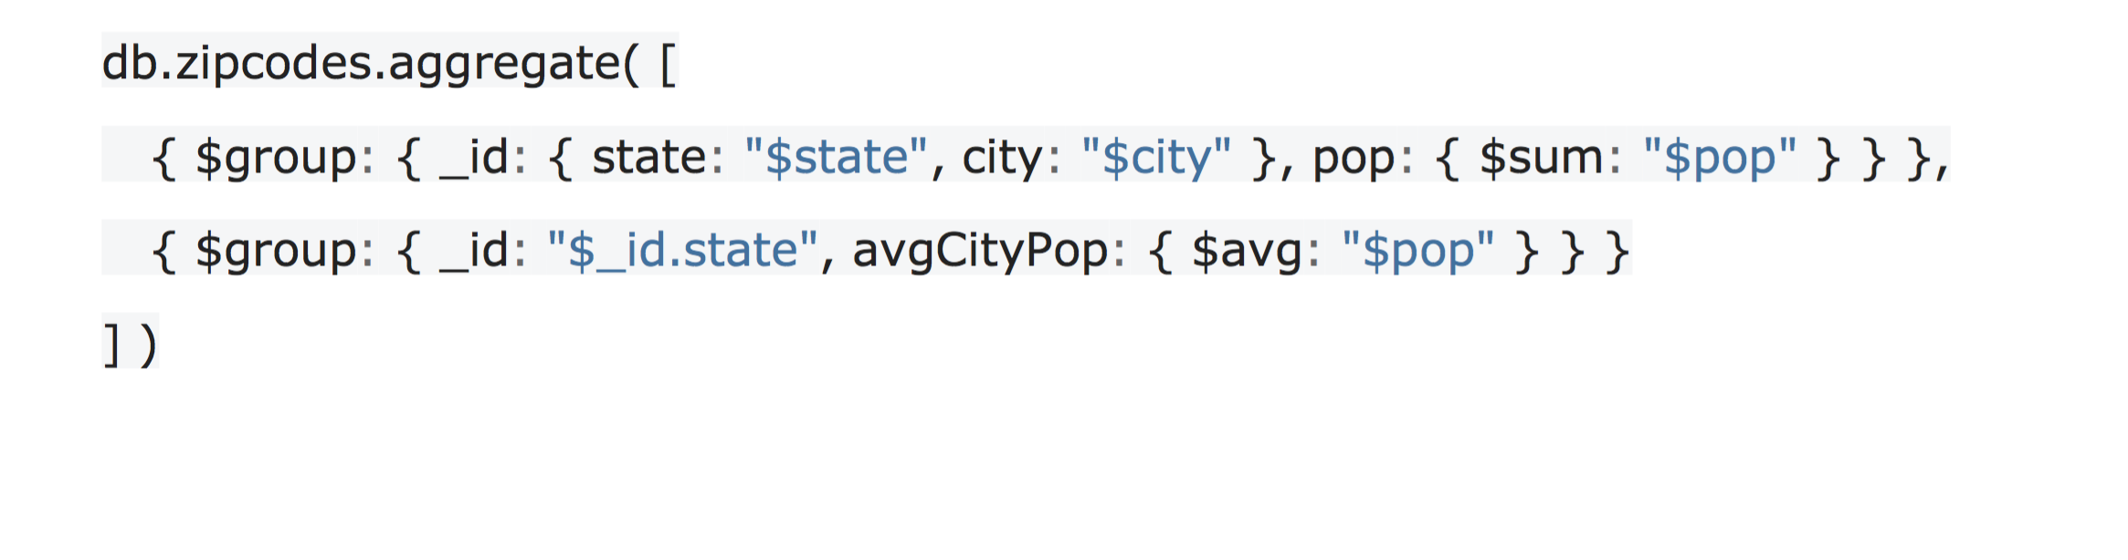

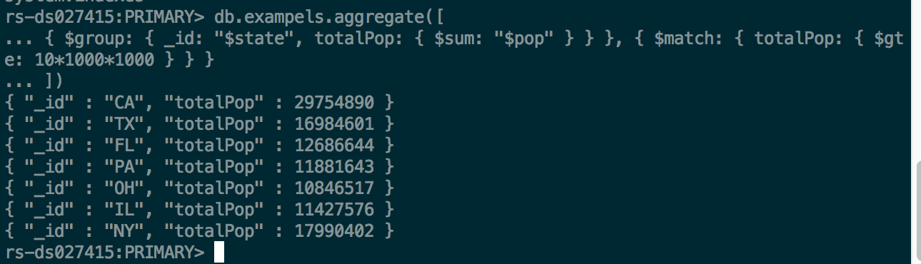

Example2:

